CENWP-OD-D 1/9/2023

MEMORANDUM FOR THE RECORD 23TDA1

SUBJECT: North Fishladder Mystery Mortality

On 1/1/23 a salmonid mortality was noticed atop a ledge in the north fishladder during a fishway inspection. The north fishladder was in full operation. Possible causes include river otters leaving prey on ledge or drifted into eddy during higher tailwater after death.

- Species –Adult Coho
- Origin –NA
- Length –NA
- Marks and tags –NA
- Marks and Injuries found on carcass –None visible from distance
- Cause and Time of Death –unknown
- Future and Preventative Measures –none at this time

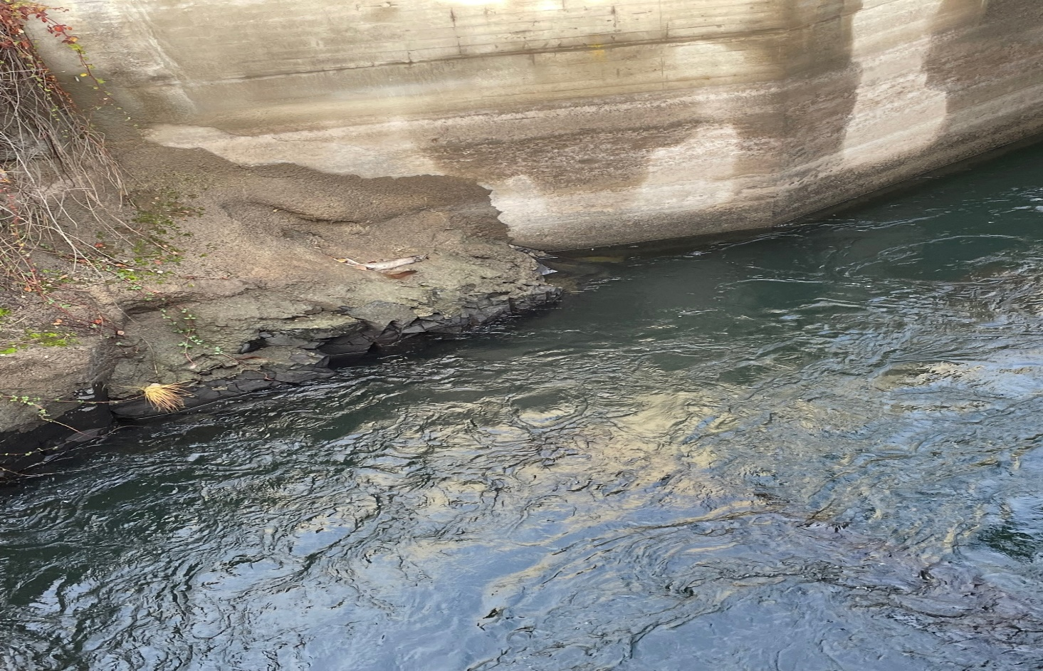

Sincerely,
Project Fisheries

